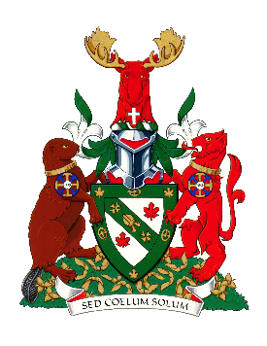

Renison University College

certifies by this document that

Fayzulloh Ergashev

served as a

Fall 2022

One Sky Festival Volunteer

Your contribution to the festival has been most appreciated and valued.

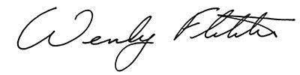

Wendy L. Fletcher, Ph.D.

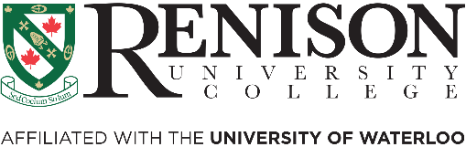President and Vice-Chancellor